1. Test whether two vectors are exactly equal (element by element).

vec1 = c(rownames(mtcars[1:15,]))

vec2 = c(rownames(mtcars[11:25,]))

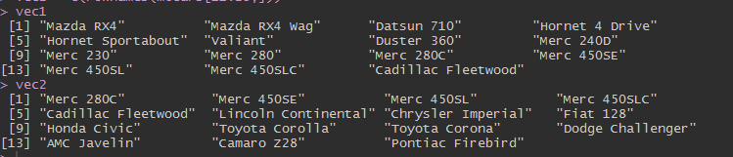

2. Sort the character vector in ascending order and descending order.

vec1 = c(rownames(mtcars[1:15,]))

vec2 = c(rownames(mtcars[11:25,]))

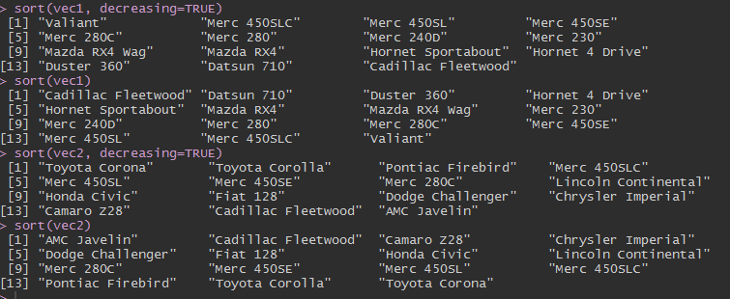

3. What is the major difference between str() and paste() show an example.

Compactly display the internal structure of an **R** object, a diagnostic **function** and an alternative to summary (and to some extent, dput ). Ideally, only one line for each 'basic' structure is displayed. ... The idea is to give reasonable output for any **R**object. It calls args for (non-primitive) **function** objects.

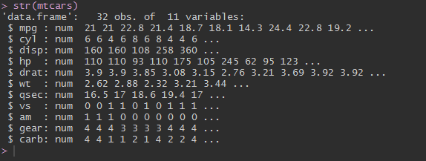

Paste function in R is used to concatenate Vectors by converting them into character. paste0 function in R simply concatenates the vector with space separator. lets see an example of paste() Function in R



4. Introduce a separator when concatenating the strings.

